theory of natural selection was proposed by
A. Mendel
B. Weismann
C. Lamarck
D. Darwin
ANSWER: D
The book "Origin of Species" was published in the year:
A. 1809
B. 1858
C. 1859
D. 1959
ANSWER: C
Cause of struggle for existence among animals is:
A. That excessive reproduction leads to increase in number
B. That there is less availability of food to organisms
C. That there is lack of spaces for living
D. Due to all of these reasons
ANSWER: D
In which of the following books, Darwin published his theory:
A. "Principles of population"
B. "On the origin of species by Natural Selection"
C. "Genetic and origin of species"
D. Philosophie zoologique
ANSWER: B
How did Darwin's finches help support his theory of evolution?
A. The birds were different colors, which allowed for camouflage in different habitats
B. Only the largest birds had survived on the island, while the smaller ones went extinct
C. The size and shape of their beaks varied, allowing them to consume a greater variety of food sources
D. The finches all lived on different islands in order to survive
ANSWER: C
Match the scientists and their contributions in the field of evolution.
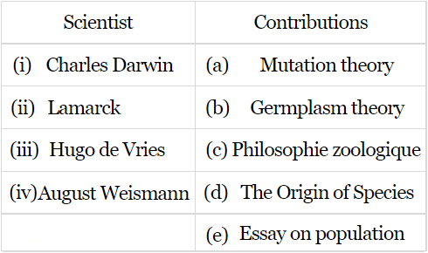
A. (i)-(d), (ii)-(c), (iii)-(a), (iv)-(e)
B. (i)-(a), (ii)-(d), (iii)-(a), (iv)-(c)
C. (i)-(e), (ii)-(d), (iii)-(a), (iv)-(c)
D. (i)-(d), (ii)-(c), (iii)-(a), (iv)-(b)
ANSWER: D
Theory of Natural Selection was presented by:
A. Mendel
B. Weismann
C. Lamarck
D. Darwin
ANSWER: D
Struggle for existence among the members of same species is:
A. Inter-specific struggle
B. Specific struggle
C. Intra-specific struggle
D. Environmental struggle
ANSWER: C
Darwin used the expression __________ rather than evolution
A. Ancestor with modification
B. Descent with modification
C. Phylogeny
D. Principle of population
ANSWER: B
Fitness is measured by an organism's ability to:
A. Survive
B. Reproduce
C. Both A and B
D. None of these
ANSWER: C
A housefly lays ____ eggs, ____ times in every summer
A. 150, 7
B. 200, 6
C. 120, 6
D. 250, 8
ANSWER: C
Elephants has an active breeding period of ______ years.
A. 20
B. 50
C. 80
D. 60
ANSWER: D
According to Darwin _________ is the driving force behind evolution.
A. Special creation
B. Natural Selection
C. Struggle for existence
D. None of these
ANSWER: B
Origin of species is written by______
A. Lamarck’s
B. Darwin
C. Hardy
D. Weismann
ANSWER: B
The idea of "Survival of fittest" was first presented by:
A. Lyell
B. Mendel
C. Darwin
D. Spencer
ANSWER: D

AN

